**Cube Status Website MVC – Summary Overview**

C. Grant Anderson

March 11, 2018

**Overview:**

The Cube Status Website MVC is an ASP.NET MVC version of the cube status components of Cube Portals that I designed and built for AT&T and other companies in my career.

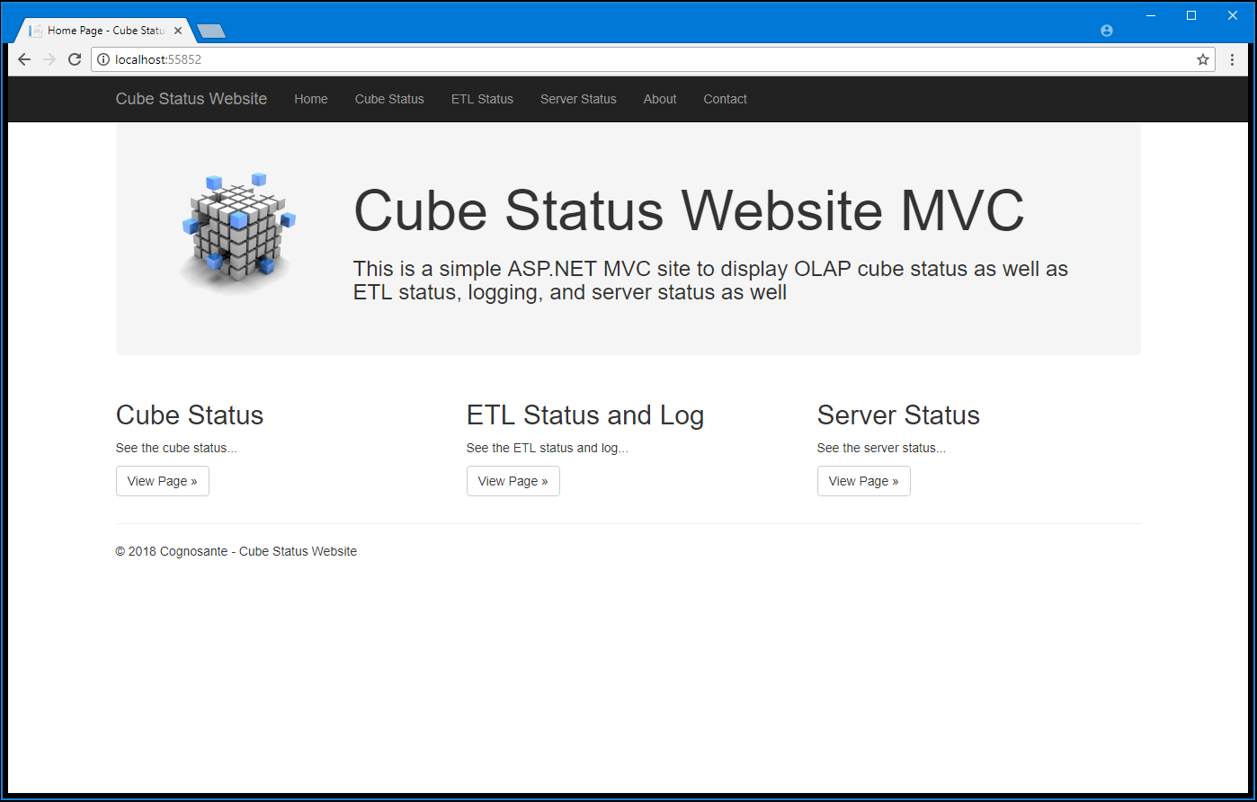

The purpose of a Cube Portal is to provide a one stop place for cube report users to go for cube and ETL status, web report access, news and maintenance notices, documentation, and other useful real time information that will help people use the cubes productively and efficiently. I consider a Cube Portal a best practice and will have a chapter in my book, “The OLAP Cube Best Practices Source Book” that is currently in development. I mention Cube Portals in my book, “The OLAP Cube Users Answers Book” and recommend that cubes users request a Cube Portal if they do not have one. My experiences at other companies show me that users use, appreciate, and need Cube Portals. And it’s a great place to connect with web reports as well.

**Important Questions Answered**

Note that this working website is but a portion of the functionality of a full Cube Portal. Specifically, one of the most important functions of a Cube Portal and answers questions important to the cube users including:

* What is the status of the Cubes? Are they up or down?
* When were the cubes last processed?
* Do the cubes contain the latest data from the ETL system?
* Is the ETL system working properly?
* Are the servers and the database servers up and running?

**A Full Cube Portal:**

A full Cube Portal will consist of additional web pages and functionality including:

1. A Landing Page showing:
   1. A summary of the system status…i.e. a nice green indicator that indicates all is well (or not).
   2. A News display which is highly useful for showing upcoming maintenance periods as well as current news pertinent to the system.
   3. A set of web links or buttons to access the most commonly used functions.
   4. Note that in sophisticated portals the main page can be a dashboard type page.
2. Status Pages to show the current real time statuses of:
   1. The Cubes
   2. The ETL and data freshness
   3. The Databases
   4. The Servers
3. Web Reports Pages to provide convenient links to web-based reports and reporting.
4. Documentation Pages to provide online documentation for the cube.
   1. Note that I believe that documentation (and training) is essential for cube users and when permitted I will document the design, development, and user level documentation needed for a good cube system.
5. A Help Page or two to get common help information as well as a page or link to log help requests.
6. Links to other useful system information and resources.
7. And a simple logging system to track user use of the portal especially what reports they run and logging of any problems they encounter when running reports.

**Pages:**

The Cube Status Website MVC consists of these pages:

1. Main Page
2. Cube Status Page
3. ETL Status and Log Page
4. Server Status Page
5. Contact Page
6. About Page

Main Page:

This is the main page of the Cube Status Website MVC. A near term future version will have a summary display of entire system status showing all ok in green, suspect components in yellow, and problems in red.



From this page a user can navigate to the three main pages – Cube, ETL, and Server Status via the three well displayed buttons. The top menu also provides access to all three of these pages as well as the About and Contact pages.

Cube Status Page:

The Cube Status page provides a summary display of the three most important user questions regarding OLAP cubes:

1. What are the cubes available (and their names)?
2. Are the cubes online?
3. When were the cubes last processed?

Each of these questions are answered in a simple table display listing all of the cubes available on the cube server. Note that this list is automatically displayed for all the cubes on the SSAS (SQL Server Analysis Server) server. A future configuration file enhancement will provide the ability to “hide” cubes that are not yet available for production use.

The display provides real time answers to these questions in a simple display. Good statuses (“OK”) are displayed in green and bad statuses are displayed in red.

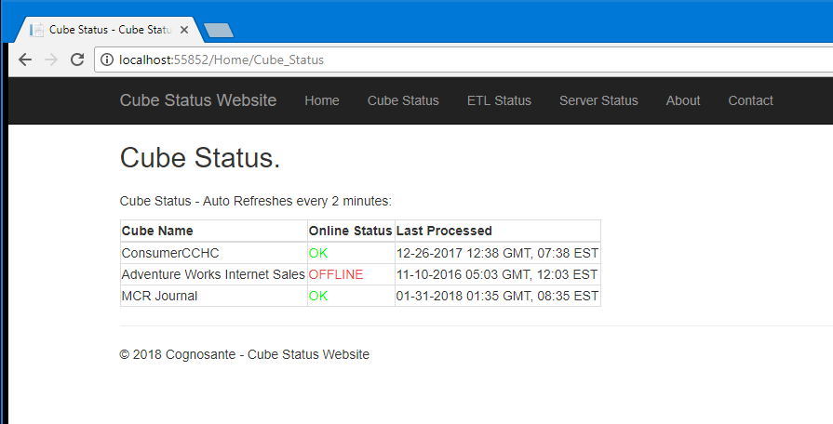

Note that this display is automatically updated/refreshed every 120 seconds (2 minutes).

ETL Status and Log Page:

The ETL Status and Log page provides a display of the last 25 most recent ETL events in the ETL log. The ETL log is the instrumentation of the cube loading SQL and stored procedures with logging statements that log useful information to an ETL log table. This provides a real time and audit trail of what the ETL did, problems it encountered, and the elapsed time for each step so that performance monitoring and optimization can be done.

Note that this display screen shot shows test data. A production deployment would show similar information. This display will be used for production ETL logging and monitoring for the MCR cube. And the display will be extended to show a simple status summary as on the other pages and an enhanced table/grid display with paging.

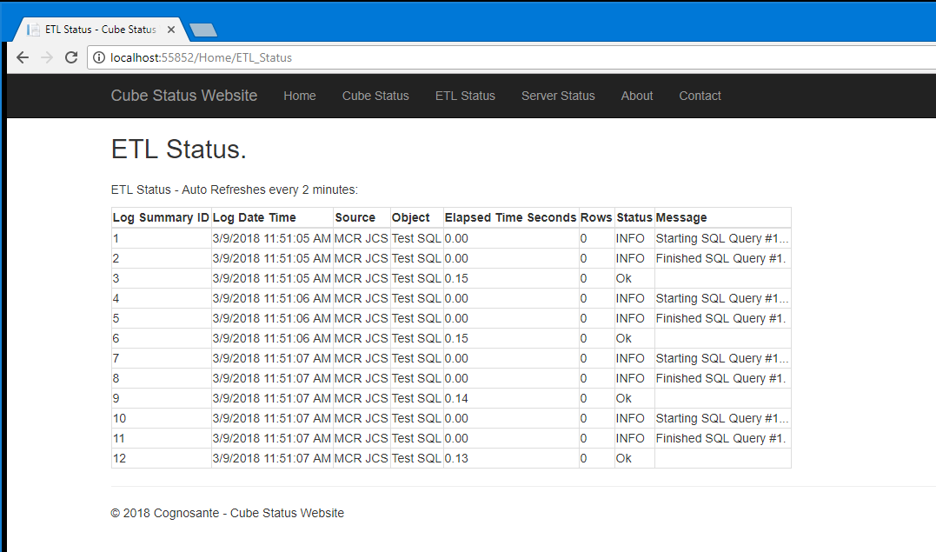

Note that this display is automatically updated/refreshed every 120 seconds (2 minutes).

Server Status Page:

The Server Status page provide a simple display of three important pieces of system information:

1. What are the servers (names)?
2. Are they up and online?
3. Is the SQL Server database(s) up and online and accessible?

The display provides real time answers to these questions in a simple display. Good statuses (“OK”) are displayed in green and bad statuses are displayed in red.

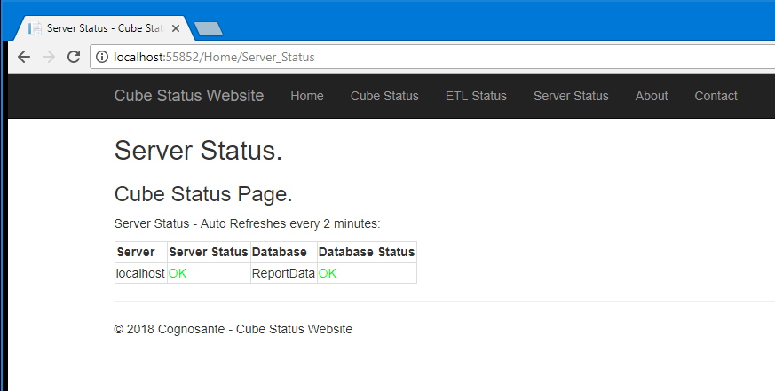

Note that this display is automatically updated/refreshed every 120 seconds (2 minutes).

**Technologies Used:**

Technologies used in this website include:

* ASP.NET MVC C#
* HTML5
* CSS
* Bootstrap
* Razor for HTML data display
* System.NET for server up/down ping access
* ADO.NET for database access and SQL queries
* ADOMD.NET and TOM (Tabular Object Model) for cube access and MDX queries
* SQL Server 2016
* Transact SQL

**Future Enhancements:**

Future planned enhancements include:

1. Configuration file support to set cubes, databases, ETL logs, and servers to monitor.
2. Enhancing ETL logging via the use of SQL CLR C# functions to reduce the amount and complexity of SQL log statements needed.
3. Putting a green/red status summary on the Main Page.
4. UX enabled setting of the automatic refresh period (currently set to 120 seconds/2 minutes).
5. And no doubt some more based upon user feedback and suggestions.
6. This can also provide a good start for a full Cube Portal and Dashboard system.